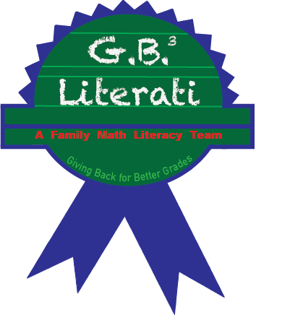

PHOTO/VIDEO
RELEASE FORM

I hereby authorize GB 3 Literati and those acting pursuant to its authority to: (i) record my likeness and/or voice on a video, audio photographic, digital, electronic or any other medium; (ii) use my name and biographical material, and such recordings; and (iii) use, reproduce, exhibit, and/or distribute my name, biographical material, and such recordings in any medium (e.g.,) for promotional, advertising, educational, compensation and/or other lawful purposes. I release and waive any claims or rights of compensation or ownership regarding such uses and understand that all such recordings shall remain the property of the Tutoring Program. I certify that I am 18 years of age or older or that parent /guardian has signed below.

Name of Participant (please print) ___________________________

Participant’s Signature ______________________________

Parent/Guardian Signature (if Participant is under 18 years of age): _______________________

Date _______________________________

Phone Number ____________________________

Email ____________________________________

